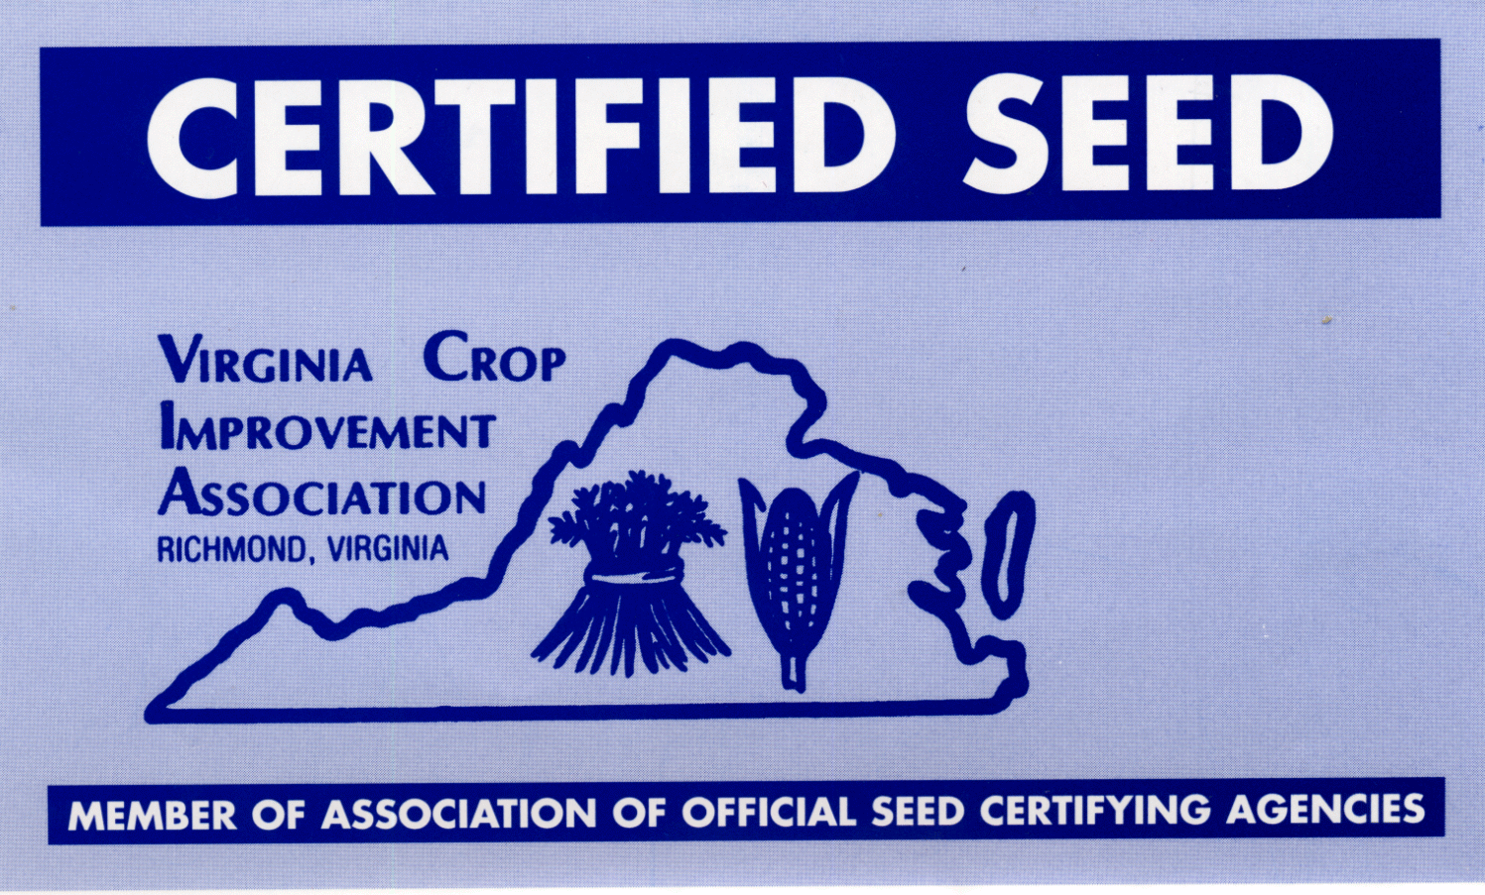 ***Virginia Crop Improvement Association***

***Foundation Seed Farm***

PO Box 78, Mount Holly, VA 22524

4200 Cople Hwy, Montross, VA 22520

Phone: 919-616-1026

**Full-Time Opportunity in Seed Production & Processing**  
The Virginia Crop Improvement Association is looking for a dependable, skilled individual to support our seed production and processing operations at the VCIA Foundation Seed Farm in Mt. Holly, VA. This position guarantees 40 hours per week with overtime hours during peak harvest seasons, vacation and sick leave. Full benefits that include health insurance and retirement.

**Key Responsibilities:**

* Operating and maintaining equipment
* Seed processing and quality control
* Conducting field inspections and rouging
* Assisting with planting and harvesting operations

**Qualifications:**

* + Candidate must be 18 years or older.
  + Good Communication and Ability to work well with others
  + Good mechanical skills
  + Large Equipment Operation (farm equipment a plus)
  + Ability to lift up to 50 lbs and climb as needed.
  + Farming background preferred.

**Anticipated Hiring Pay** : $18.00/hr

**How to Apply:**

Applications are available from the Virginia Crop Improvement Association located at 4200 Cople Hwy. Montross, Va 22520 or Online at **virginiacrop.org.**

If you have any questions, please contact Charlie (919) 616-1026